cladding crisis driving owners to the brink

Nina Hendy – *The Urban Developer – 29 June 2021*

A number of developers and building owners are facing financial ruin as the fallout of the combustible cladding crisis widens in Australia.

Authorities have now identified more than 3400 residential apartment buildings as having cladding deemed flammable.

Fixing the cladding crisis will cost billions. The issue is being dealt with state-by-state, with [governments handling the rectification works](https://www.theurbandeveloper.com/articles/nsw-combustible-composite-cladding-remidiation)—no mean feat during a global pandemic and construction materials [supply shortage](https://www.theurbandeveloper.com/articles/home-building-development-construction-costs).

In Victoria alone at [least 71 buildings have been classified](https://www.theurbandeveloper.com/articles/cladding-ban-developers-victoria) as “extreme risk” and another 368 as “high risk”.

Despite evidence of the risks of cladding fires, reports suggest that rectification work has been completed on just 11 of these buildings as of February this year.

Meanwhile, owners or occupants of lower-risk buildings have largely been left to fund the rectification work themselves. Fines are being issued, too.

This big issue is that the laws, policies and programs relating to combustible cladding and non-compliant building materials continue to evolve as governments take steps to regulate the industry, and provide owners with guidance and financial support.

Developers are facing an expensive replacement program during a global pandemic and a [major slowdown of construction material](https://www.theurbandeveloper.com/articles/sydney-construction-costs) supplies. A shortage of builders means the process will take years, and billions of dollars, to resolve, pushing developers to the brink and some into bankruptcy.

Authorities involved in resolving the crisis have apportioned the blame to certifiers, insurers, installers or developers and in some cases, all of the above. The full implications for developers and building owners are not yet clear.

In Australia, the cost to rectify the defects falls to homeowners, however, there is limited information about how much the replacement will cost. There are stories about developers caught out, left holding the bill for a building that has dropped significantly in value.

One [researcher who interviewed affected homeowners](https://www.tandfonline.com/doi/abs/10.1080/19491247.2021.1893119?journalCode=reuj20) in Australia identified a range of costs to rectify the issue, including increasing levies, body corporation fees, insurance rates, council rates, legal fees, marketing testing and inspection costs.

The research revealed that the quoted costs of rectification work ranged from $30,000 to $12 million depending on the scope of works required. The costs associated with cladding rectification has created significant financial burdens for households and influenced life decisions related to finances.

Meanwhile, insurance companies keen to sidestep the crisis have started to ask for more details about cladding materials, requiring details such as the type of material, location, manufacturer and certifications.

**The global problem**

Australia is just one country facing up to the problem—28 per cent of buildings around the world have been deemed unsafe due to combustible cladding.

The issue came to light in London with the Grenfell tower disaster in 2017 that claimed 27 lives. The tower block still has flammable cladding in places and recent media reports revealed that flat owners are receiving bills to make the buildings safe. Most have been left reeling at news that the bill to replace the faulty cladding exceeds the value of their homes.

It’s a similar story in the US, where uninsurable apartments sit idle, deemed worthless due to the crisis, unable to be sold. Even if a buyer is found, mortgage lenders are nervous about lending to those wanting to purchase a property in a suspect clad building.

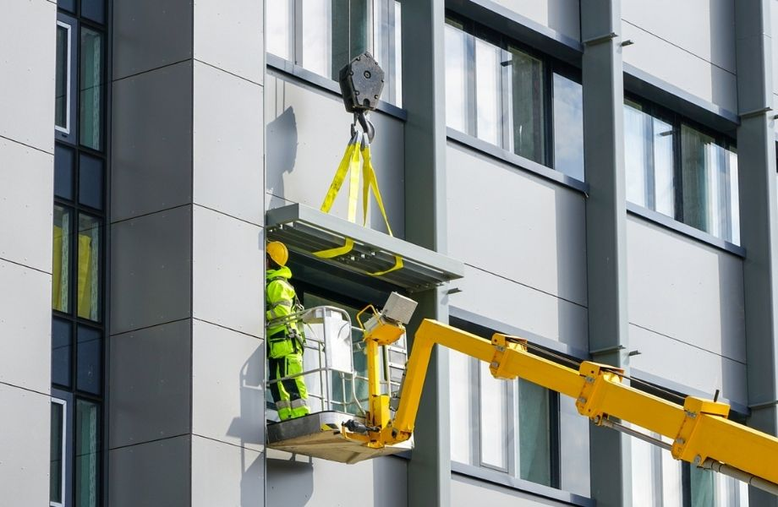

▲ The remediation of cladding deemed dangerous has, in Australia, been far from a clear-cut process so far.

**NSW**

In NSW, the state’s [cladding taskforce](https://www.theurbandeveloper.com/articles/nsw-combustible-composite-cladding-remidiation) has audited 185,000 building records and so far 4127 inspections have been conducted with 3755 buildings cleared and 372 [under review, assessment or remediation](https://www.nsw.gov.au/nsw-cladding-taskforce) as of February 26, 2021.

So far, 225 buildings in the state have been deemed high risk. They are able to be registered interest in Project Remediate, which aims to remove high-risk combustible cladding from residential apartment buildings.

Meanwhile, 50 strata communities in NSW have registered for the government’s program to remove combustible cladding from residential apartments.

The communities that have registered for the $139-million program will have their building assessed and a remediation design prepared before they decide whether to commit to the work.

Apartment owners forced to replace flammable cladding on high-risk buildings in NSW can access interest-free loans as part of a $1-billion government program during the next three years.

**Victoria**

There are 695 high-risk buildings in [Victoria](https://www.theurbandeveloper.com/articles/apartment-development-victoria-richard-wynne). Here, the finger of blame is being pointed squarely at building practitioners—including builders, surveyors and fire engineers.

Dozens of these specialists linked to 790 properties with unsafe, [non-compliant combustible cladding](https://www.theurbandeveloper.com/articles/-victoria-fast-tracks-combustible-cladding-scheme) have been the subject to enforcement action by the Victorian Building Authority. Non-compliance means risking fines of up to $400,000.

The statewide cladding audit has inspected more than 3200 properties since it began in 2018. The state believes holding building practitioners to account for their actions sends a clear message that unsafe, non-compliant work won’t be tolerated.

“We’ve taken decisive action against those practitioners who have put the lives of Victorians at risk through the use of non-compliant, combustible cladding,” Victorian Building Authority CEO Sue Eddy said.

“The use of non-compliant combustible cladding has led to immense stress and heartache for homeowners and caused untold damage to the reputation of the industry.”

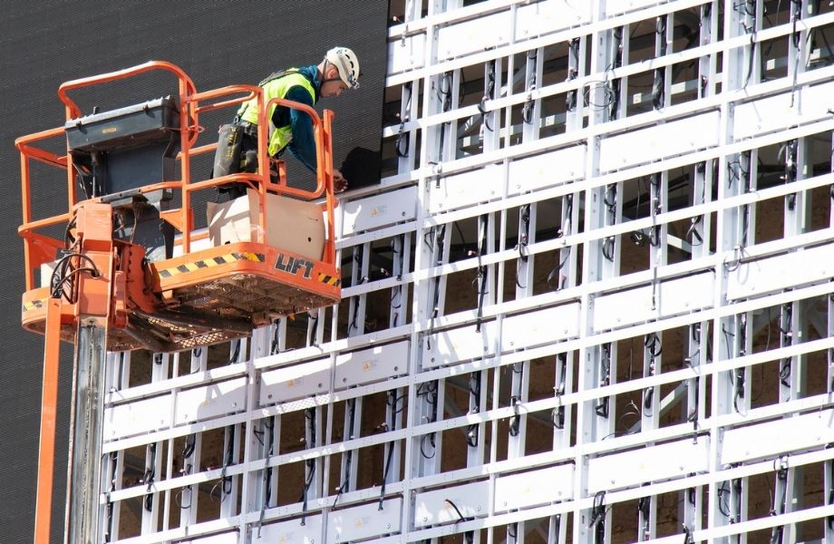

▲ Owners and occupants of affected buildings are facing financial hardship and mental anguish as the cladding crisis plays out.

**Queensland**

Dozens of building practitioners who have not completed the process of eliminating the risk of catastrophic building fires caused by combustible cladding will be hit with fines.

The Safer Buildings Program has cleared 17,365 buildings of potentially combustible cladding since 2018 but is [threatening fines](https://www.qbcc.qld.gov.au/media-releases/clock-ticking-dangerous-cladding)of $22,000 if rectification works aren’t completed.

While 90 per cent of builders have completed the process in the past two years, the program has confirmed that it is collating a list of builders fined due to be made public in coming weeks.

**No easy solution**

Anthony Lee, general manager at Brisbane cladding facade company Exintech, has been watching the fallout of the cladding crisis for three years.

He tells of a developer being told the replacement cost would be $100,000. But the replacement product was also deemed faulty after installation. The replacement cost the second time around was $600,000. “And that was on a building that was only four-years-old,” he said.

“The cladding being used by the industry is so dangerous, as we’ve seen. It’s like wrapping a building in petrol.

“The fall-out from Grenfell hasn’t fully impacted us yet. The costs involved here are going to be astronomical, and developers aren’t going to know what’s hit them.”

Lee has spent the past three years looking for a solution, manufacturing a replacement product he claims is the world’s safest fire-resistant cladding. The new class of non-combustible cladding was created from chemically fused zinc-annealed steel and aluminium.

Exintech’s fused steel panel can withstand temperatures in excess of 1000 degrees celsius dropping less than 100 grams of ash debris from the 9m full scale fire test structure—a test adopted under the British Standard BS 8414.

Meanwhile, it has been suggested a shift away from paper-based certifications and files to ensure that cladding products used are quicker to identify.

“A big part of the problem is that the residential building sector is bogged down in piles of paper-based records, which has slowed down the faulty cladding identification process,” according to Rob Bryant of construction project management software InEight.

In the commercial world, digital records are handed over upon completion, Bryant, the executive vice president of APAC says, and it is an important lesson for residential developers. Bryant says he can see a not-too-distant future where the handover process upon completion of residential developments will include digitalised manuals, records of construction methods used, drawings, approvals and occupancy certificates.

“Having records available digitally could even impact the property purchase price in the future given all the doubt in the market due to the cladding issue.”